**The border and customs**

At the end of our Municipality’s public wharf at Cedarville, there is a telephone in a yellow box. The phone and an accompanying large sign which spells out certain legal obligations, are the property of the Canada Customs and Revenue Agency. The phone was put into service in the 1970's establishing, or more correctly re-establishing, a Customs presence, albeit a token impersonal one, in Cedarville after a lengthy hiatus.

The Custom’s phone reflects a simple reality, a reality that is largely taken for granted (and sometimes ignored) by Ogden residents, but one that looms large in the history of our Municipality and governs day-to-day our mobility in a southerly direction, for Ogden lies adjacent to an international body of water, Lake Memphremagog, and our southern boundary is coincident with Canada’s national border with the United States of America.

The history of the establishment of this border is a fascinating one, and the establishment of Customs in this area is a parochial tale of intransigence, intriguing ironies and petty village jealousies.

**Whither the Wastelands**

During the French Regime, the colonial administration of New France almost certainly viewed the unbroken and virtually uninhabited wilderness to the east of the Richelieu –Lake Champlain watershed and south of the St. Lawrence River, as just that, an unbroken wilderness. Most certainly it was not coveted for colonization, for there were few enough habitants even at the very end of the French regime (~ 70,000 population) to adequately scratch the potential of the colony’s existing arable land along the banks of the St. Lawrence, and Richelieu rivers. Only by the 1840’s was this ancestral land base largely exploited, with an excess of population (~240,000) sufficient to drive an agrarian need for lands further afield. Access to the region encompassing the upper St Francois River watershed was inhibited by its ruggedness, with water courses requiring an excessive number of portages. The natural resources of the region were either naturally sparse and/or depleted (furs), or prohibitively far from market (timber for ships masts).

From a geopolitical perspective, the French crown would have laid claim to much of the Abenaquis territory, and indeed that portion whose watershed flowed to the St. Lawrence (i.e. the Eastern Townships) was viewed as part of New France. However in practical terms, the crown and colonial authorities recognized the suzreignity of the various indigenous nations over this vast territory, and would at best claim the areas to be part of the French « sphere of influence ». As hostilities with the more populous English colonies on the Atlantic seaboard increased over time, the area was viewed as a most useful “buffer zone”, an impenetrable wilderness, at least to a large military force, and largely controlled by French native allies.

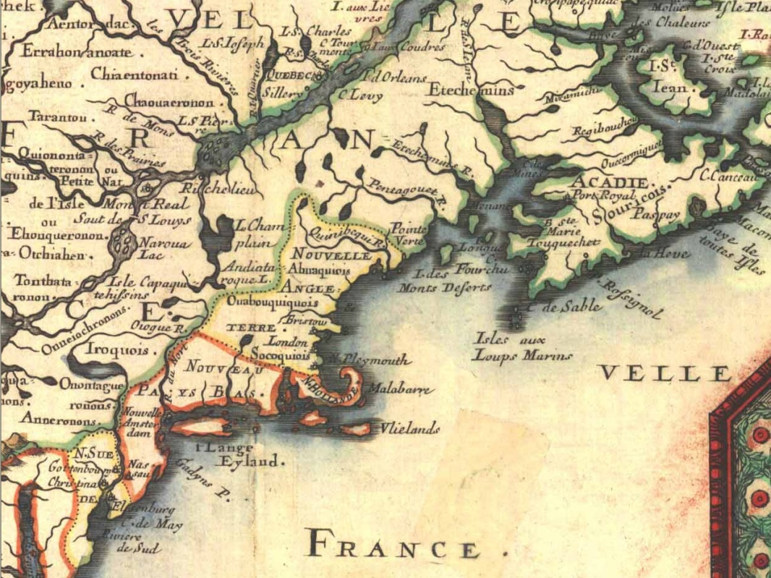

**Detail of a portion of a map by Nicolas Sanson 1656 Nouvelle France ou Le Canada. Lake Memphremagog is not indicated on this map (unkown to europeans at this time), but of interest is the French depiction of New England, constrained to an area southwest of the Kennebec River and south of the supposed height of land dividing waters that flow into the Atlantic versus the St. Lawrence.**

Prior to the Conquest, no formal boundary between New France and New England had ever been agreed upon. However the 45o North Latitude had been employed historically as a boundary by both the Dutch and the English as a northerly bound for their colonies, and when the British formally took control of New France in 1763, they arbitrarily used this same convention as marking the boundary between New York and the new province of Quebec.

For reasons that remain unclear, in the period 1763 to 1774 the British allowed no settlement or awarding of land grants in the wilderness between the Yamaska and Chaudière Rivers south to the newly defined border. In the meantime the governors of New Hampshire and New York were busily slicing up their northerly wilderness areas into saleable tracts of land. As unrest turned into revolt in the 13 Colonies, the British were very happy to have inherited the French buffer zone. In 1775 the impenetrability of the wilderness to a large military force was amply demonstrated by the disasters that befell the rebel general Benedict Arnold and his army, as they barely were able to find their way through the Maine wilderness to the Chaudière River, losing almost half their men in the process[1].

With the close of the American Revolution and the signing of the Treaty of Paris in 1783, the New York - Quebec provincial boundary became an international one. However now the British were even more determined to maintain a wilderness buffer zone, hoping to prevent close contact between the Americans, with their dangerous ideas of republicanism and representative government, and a Canadien populace, ripe for subversion! Only in 1792 were the wastelands of the crown open for settlement, but even following a flood of settlers into the Townships, local control of the assumed but ill-defined border in the Township of Stanstead would wait until 1821. The border itself would not be finally fixed until 1842.

1. Of Arnold’s 1,100 man army, only about 600 freezing and starving troops made it to the first French Canadian farms on the upper Chaudière.